|  |  |  |
| --- | --- | --- |
| **Kingdom of Saudi Arabia**  **Ministry of Education**  **University of Hail**  **College of Computer Science and Engineering**  **Department of Computer Engineering** |  | **المملكة العربية السعودية**  **وزارة التعليم**  **جامعة حائل**  **كلية علوم وهندسة الحاسب الآلي**  **قسم هندسة الحاسب الألي** |

**Electronics - 203**

Experiment #6: Bipolar Junction Transistor Characteristics

Part#2

**Name :** Khaled Mofdi Alshammri

**Couse :** EE-203

Introduction :

in this experiment i will study transistor BJT type PNP ( PNP mean positive negative positive ) and will analysis current with software PSpice, then find beta value and alpha value with use some law to find it

Lets get started :

**B) DC Current Gain β versus collector current IC and IB: VCE  = 5V**

**for IB from 100μA to 1mA in DECADES with 20 points per decade. Run**

**the simulation. Plot the trace IC / IB versus IB. Also plot IC /IB versus IC.**

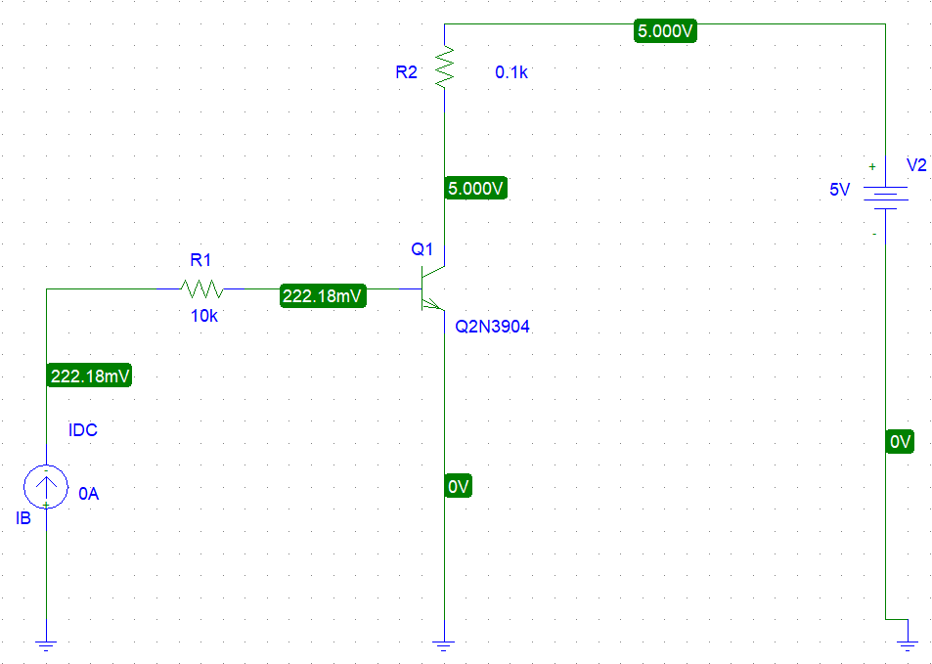

*1 ) Trace Circuit ( IC / IB  vs IB ) Current :*

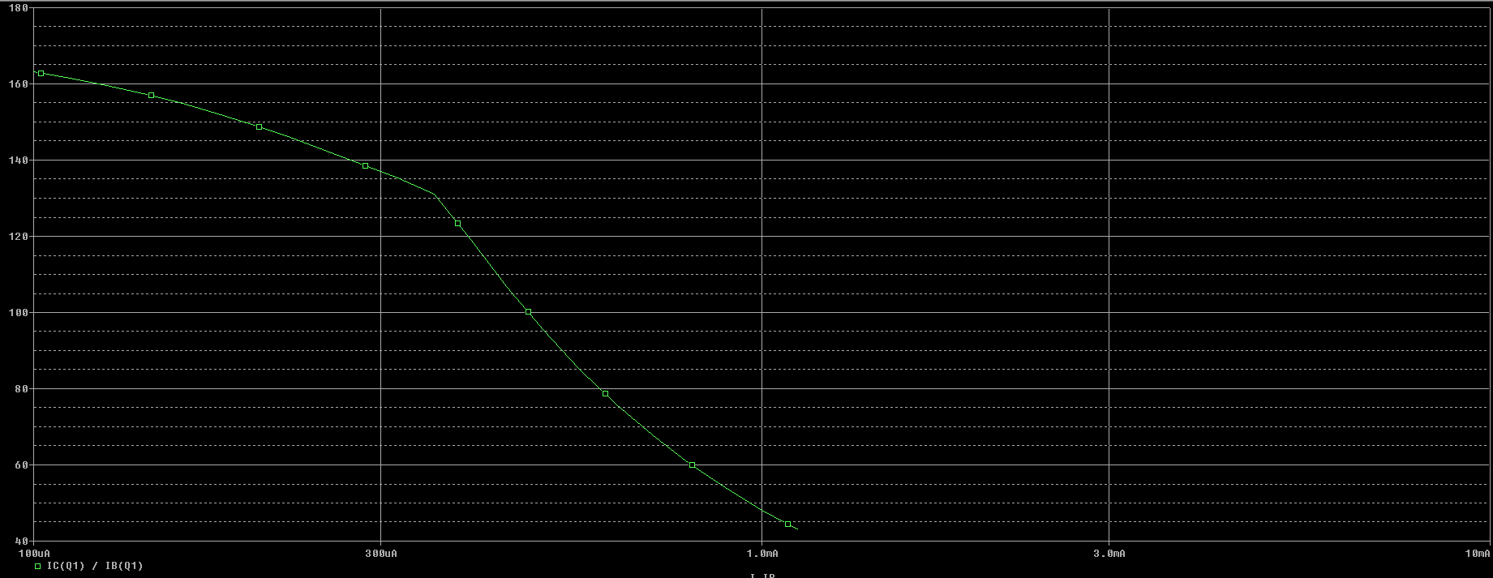

at IB = 100uA maximum

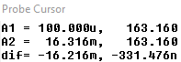

at IB = 1.0mA minimum

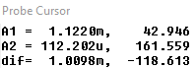

*2 ) Trace Circuit ( IC / IB  vs IC ) Current :*

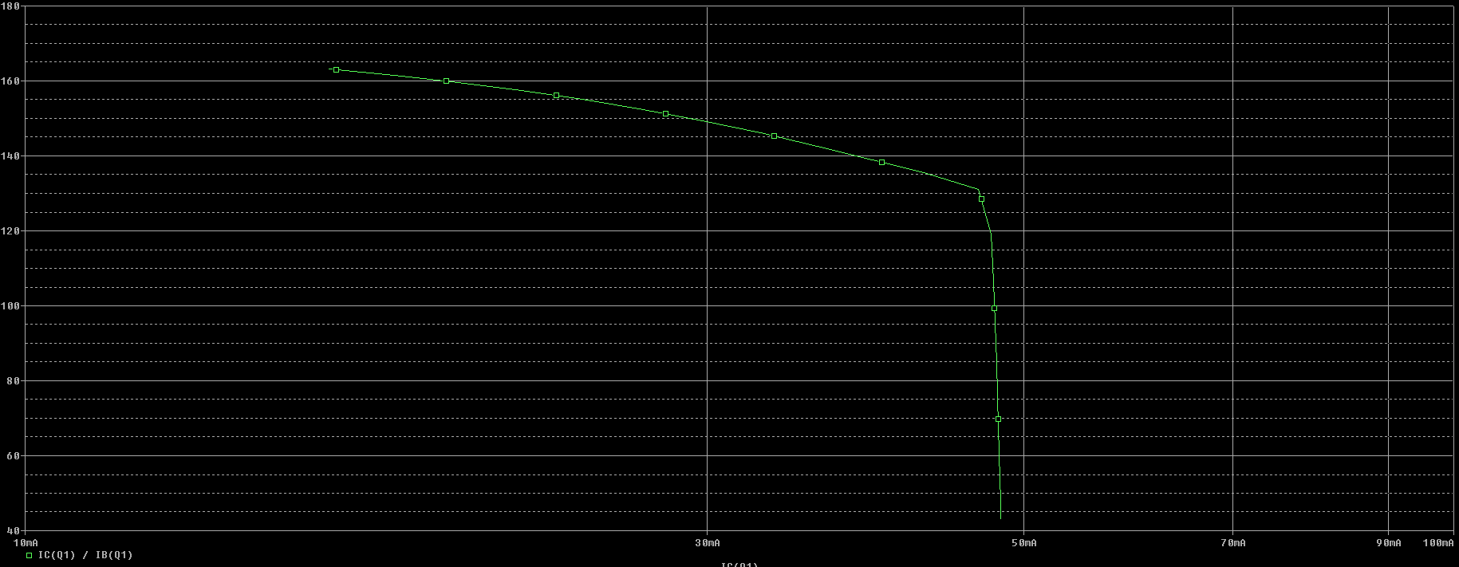

at *IC / IB* = 163.160mA , IC = 16.316mA

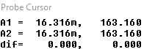

*A ) Find, from second plot, the maximum DC current gain. Find the corresponding IB and*

*IC. Determine α at calculated IC****.***

At IB  = 100uA **,**  Max = 163.160 , Ic  = 16.32mA

**To Find $α$:**

$$α=\frac{β}{β+1}=\frac{163.160}{163.160+1}=0.9939$$

**C) β versus Temperature:**

**Consider VCE = 5V .You can generate β**

**versus IC curves at different temperatures. This is a typical curve found in most data**

**sheets for BJTs.**

***3 ) Trace Circuit (* β *vs Temp) Current :***

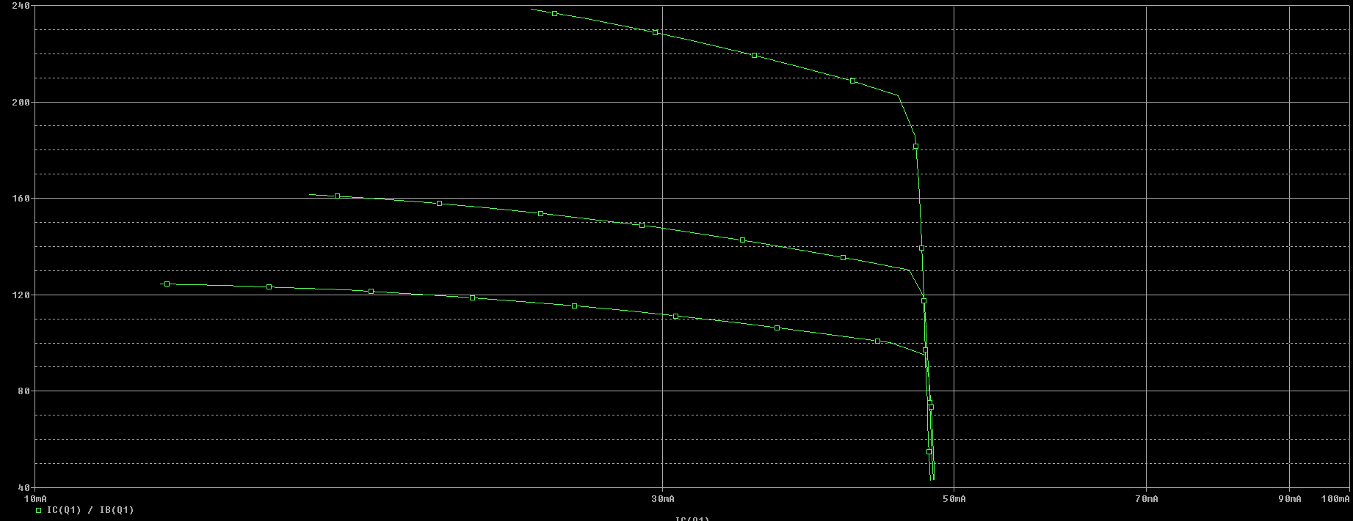

Temp values : -25, 25,125 Co

At Temp = -25 Co  Max =124.551 , IC max = 12.455 mA

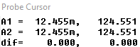

At Temp = 25 Co Max =161.650 , IC max = 16.174mA

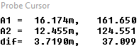

At Temp = 125 Co Max = 238.480 , ICmax = 23.878mA

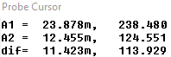

**At what IC the β is maximum?**

max = 238.480 at Ic  = 23.878mA

*Conclusion :*

In Fig ( B ) at trace *IC / IB  vs IB the maximum $β$ at IB = 100uA then after 100uA drop value until 1mA*

*In trace 2 at IC / IB  vs IC  hard drop value in point*



At Fig ( C ) when Temperature increase the value $β$ increase with Ic

**END REPORT**